**CREATIVE PACKET**

SERENA GARCIA

GRC 337-01

**COMPETITION**

**The Culinary Edge**

This company uses a logo design that is a very simple depiction of a kitchen timer that also includes the letters C and E. Out of all of the culinary consulting companies I researched, The Culinary Edge works with the most high-profile companies like Buffalo Wild Wings and AMC theaters. I found their logo very clean-looking, and together with the imagery of a timer, it comes off very professional.

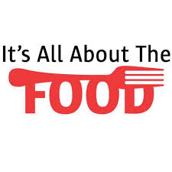**It’s All About The Food**

This New Jersey based company combined an image of a fork together with its title. The whole title seems too long aesthetically. However, I do like the contrast of the bright red color and the black because it is memorable. The font is simple enough where we can still read the whole title easily even though parts of the letters are cut off by the image of the fork.

**JK Consulting**



JK consulting is a culinary consulting group based in New York City. The title of the company says nothing about what the company does, so it was smart to include a simple table setting in the logo to let potential clients know they work with food. The bite taken out of the plate image also makes this logo original. I do not particularly like the color scheme because I don’t associate grey tones with food.

Serena Garcia

FoCo Client Profile

Innato

Culinary Consulting

With an experimental kitchen located in the heart of Seattle, Innato is a woman-owned and led consulting business designed to help their clients reach their elevated culinary goals. Innato, the Spanish word for “innate”, was chosen as the company’s title because it speaks to the ability of our earth to naturally produce so many unbelievably flavorful food ingredients. Food is very important to them, and they want to portray to their clients that good food starts from fresh and high-quality ingredients and simple but well-done cooking processes. Their five chefs with extensive culinary and food science backgrounds are eager to work with individual businesses to elevate their food products and menus and make their culinary aspirations a reality. They specialize in a wide variety of traditional and ethnic cuisines and market mostly to small and start-up restaurants and food and beverage brands. As a small business, the chefs are able to spend a lot of time aiding their individual client businesses in developing their food products as well as helping establish safe and correct practices for the client’s continued food production after they are finished working with them. They wish to reach new clients with all kinds of culinary visions for their company, whether they are fully cultivated concepts or general ideas that need some collaboration to develop further. Innato seeks to make its clients’ food dreams come true.

**MOOD BOARD**

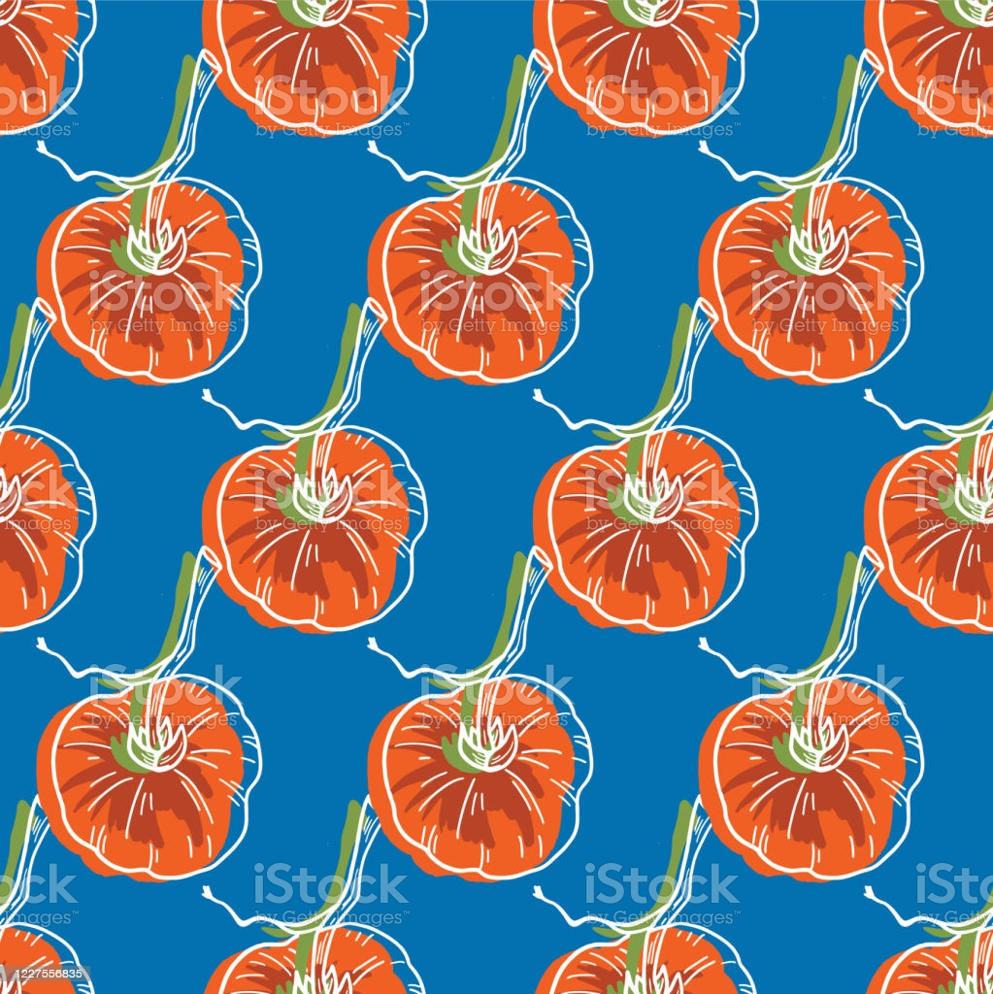

INNATO

INNATO

**INNATO**

**INNATO**

**INNATO**

**INNATO**

**INNATO**

**INNATO**

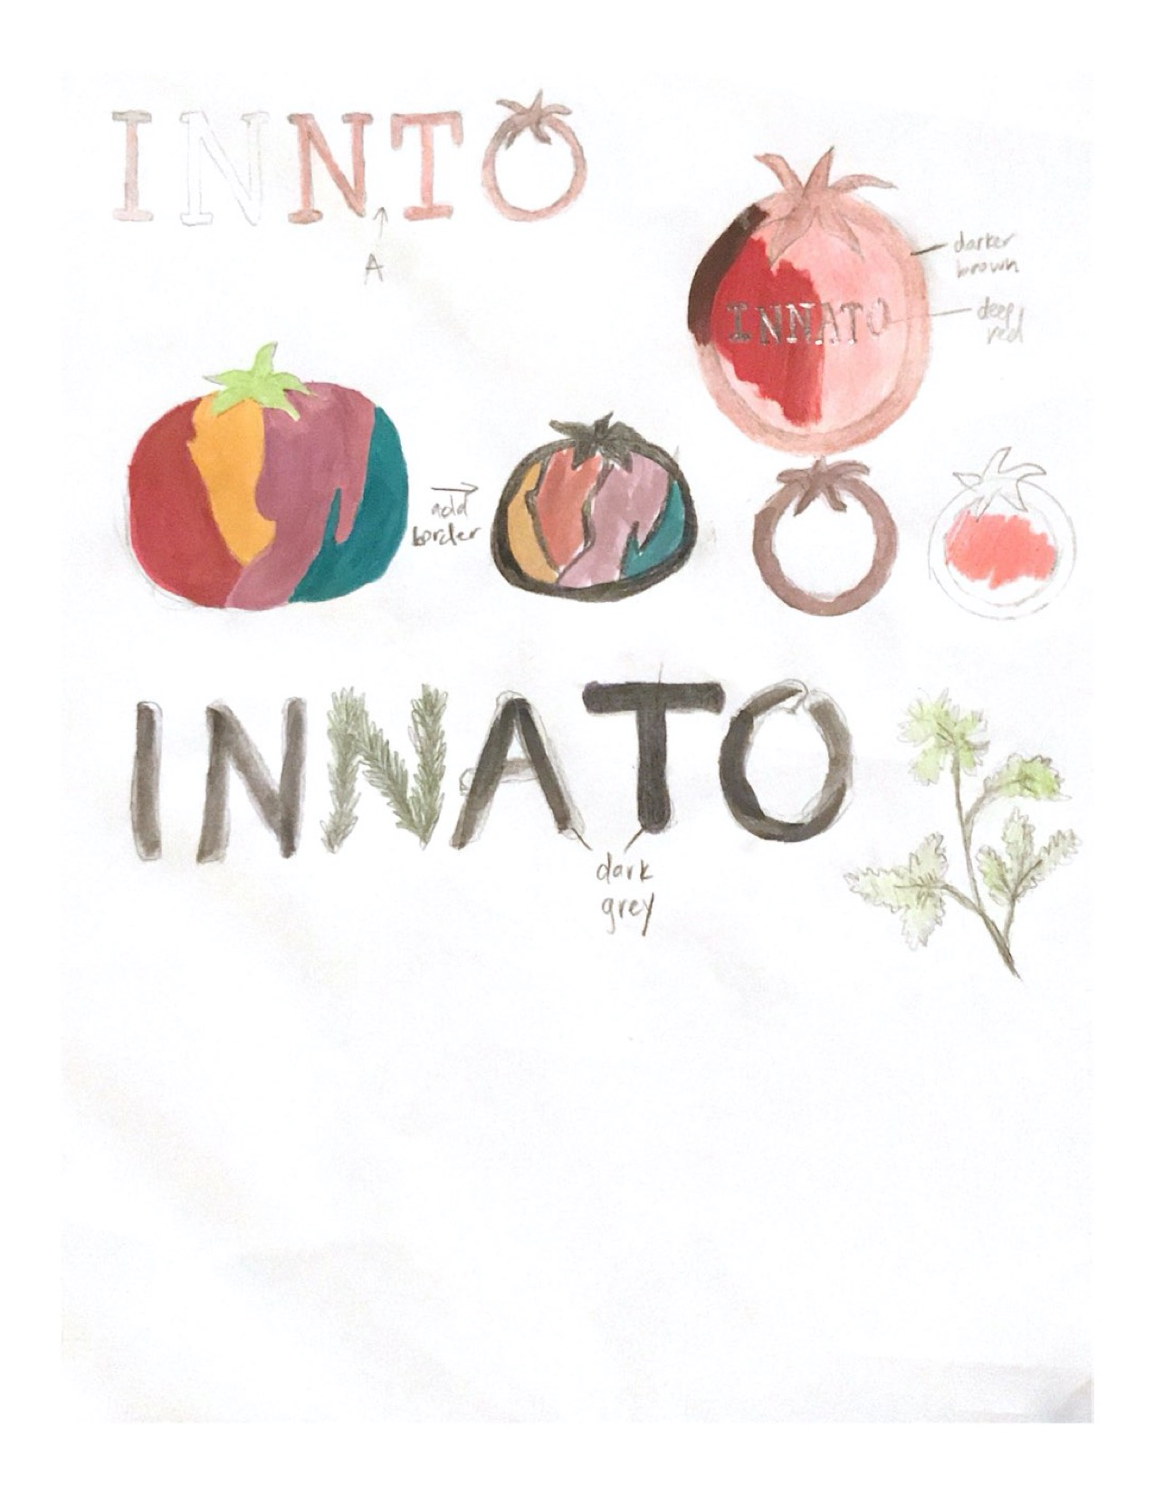**THUMBNAIL SKETCHES**